IMMINGHAM TOWN COUNCIL
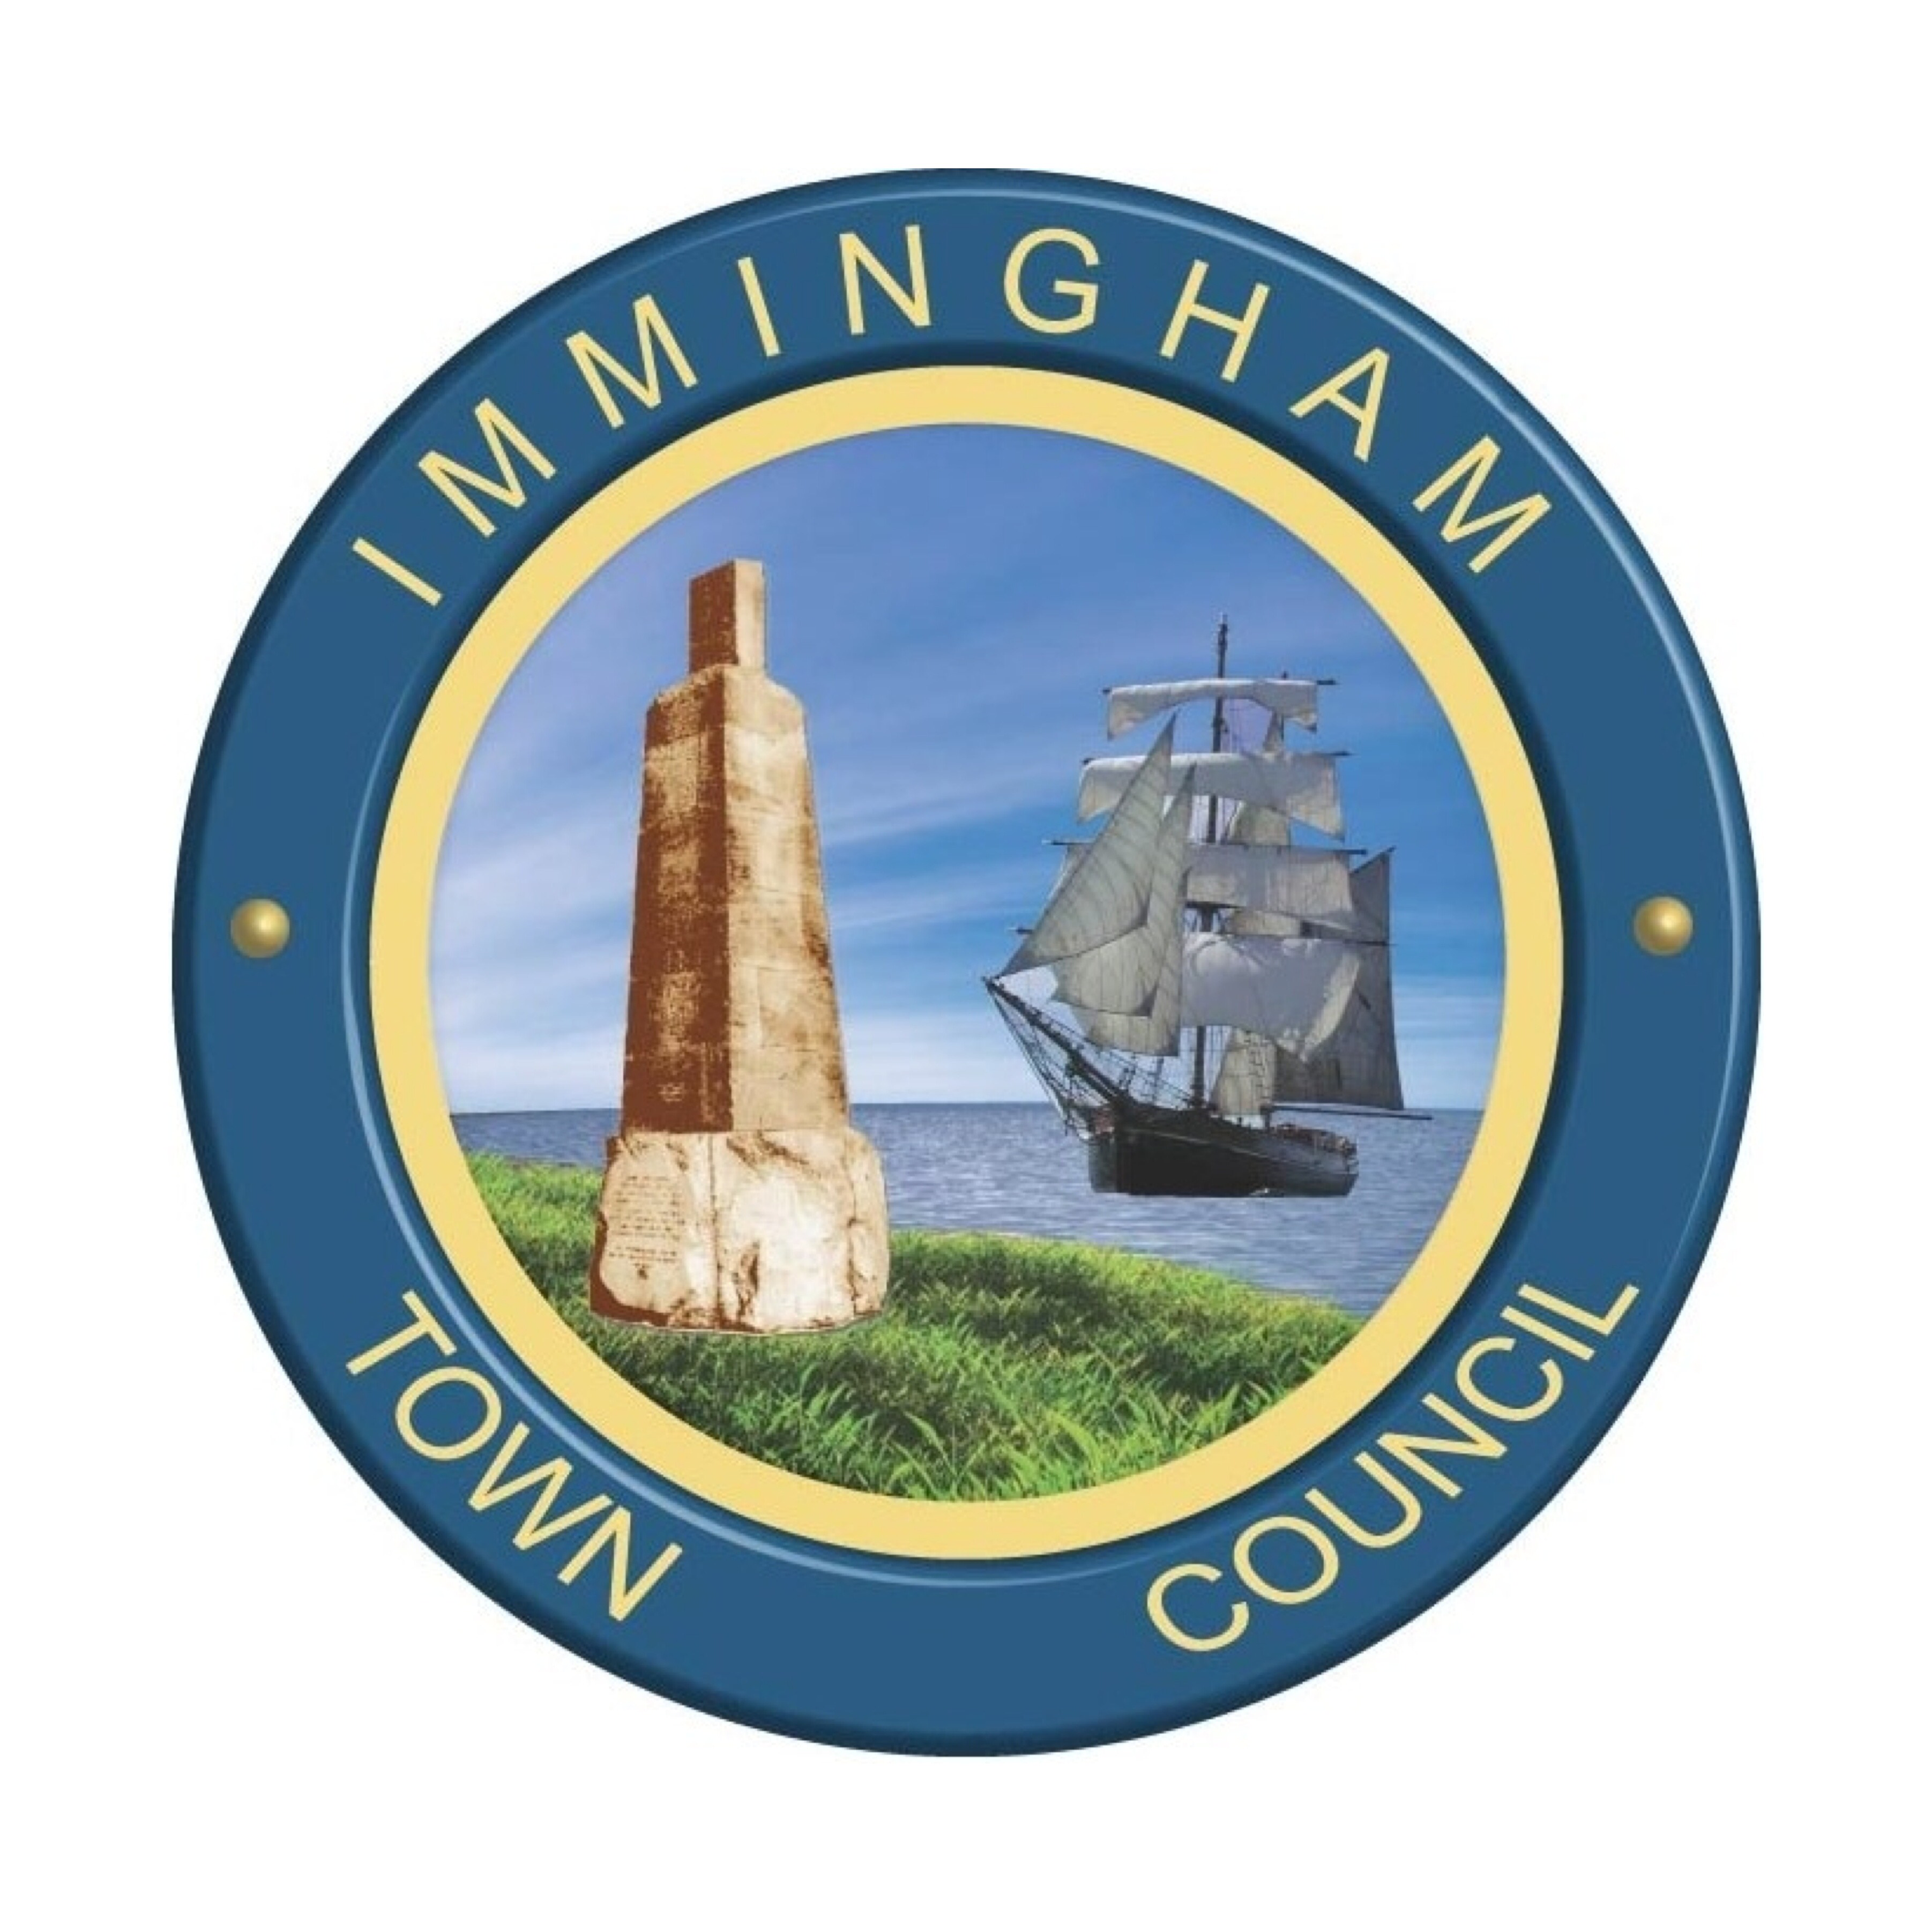
Civic Centre, Pelham Road, Immingham
North East Lincolnshire, DN40 1QF
TEL: (01469) 727272, email: enquiries@immingham-tc.gov.uk

You are invited to the ANNUAL COUNCIL MEETING of Immingham Town Council which will be held on 26 May 2021 at 19:00 Burton Hall, Civic Centre, Pelham Rd, Immingham.

Public are welcome to attend, but numbers are restricted to 30 for safety reasons.

Should you wish, you can also email andyhopkins@immingham-tc.gov.uk with items you may have raised in the public session and these will be presented to the Council on your behalf.

Also, if someone wants to view remotely please email me on the address above and I will explain how to access.

A Hopkins

A Hopkins
Town Clerk 18 May 2021

Members of the public may speak on any item(s) appearing on the public agenda.

Audio and video recording of this meeting may take place with certain restrictions.

A G E N D A

1/21 Apologies

To receive and approve any apologies for absence

2/21 Declarations of interest

- To record declarations of interest by any member of the council in respect of the agenda items listed below. Members declaring interests should identify the agenda item and type of interest being declared.
- To note dispensations given to any member of the council in respect of the agenda items listed below.

3/21 Election of Chairman

Election of Chairman to hold the office of Town Mayor for 2021/2022

4/21 Declaration of Office

To receive the Chairman’s Declaration of Acceptance of Office

5/21 Retiring Mayor

Retiring Mayor’s remarks

6/21 Vice Chairman

Election of Vice Chairman to hold the office of Deputy Mayor for the year 2021/2022

7/21 Mayors Cadet

Election of Mayor’s Cadet for the year 2021/ 2022

8/21 Mayoral Appeal

To receive details of the Mayoral Appeal for 2021/2022

9/21 Committees

To resolve Immingham Town Council Committees & membership for 2021/2022

- Policy & Scrutiny 7

- Community & Environment 7

- Personnel 5

10/21 Outside Bodies

To appoint representatives to serve on external organisations as required

11/21 Schedule of Meetings

To approve the schedule of meetings for the Town Council and Committees 2021/2022

12/21 Confirmation of Minutes
To confirm that the minutes of the following meetings are a true and correct record of that which took place:

Town Council 20th April 2021
Policy & Scrutiny 18th May 2021
Community & Environment 19th May 2021

13/21 Annual Governance and Accountability Return 2020/21

To receive the year-end financial paper work

To approve the Annual Governance Statement 2020/21

To approve the Accounting Statement and Annual Return 2020/21

14/21 Planning

To discuss planning applications received

- DM/0422/21/FUL
Proposal: Retrospective application for the change of use of adjacent public land to form part of domestic curtillage (amended ownership certificates)
Location: 8 Fairisle Rise Immingham North East Lincolnshire DN40 1RQ

- DM/0455/21/FUL
Proposal: Variation of Condition 6 (Delivery Times) as granted on DM/1157/14/FUL to extend the delivery times
Location: Aldi Washdyke Lane Immingham North East Lincolnshire

- DM/0461/21FUL
Proposal: Variation of Condition 3 (Materials) as granted on DM/1005/20/FUL - amendment to external walls from brickwork to render
Location: 62 Clyfton Crescent Immingham North East Lincolnshire DN40 2BT

